**UNIT-4**

A graph is a pictorial representation of a set of objects where some pairs of objects are connected by links. The interconnected objects are represented by points termed as **vertices**, and the links that connect the vertices are called **edges**.

Formally, a graph is a pair of sets **(V, E)**, where **V** is the set of vertices and **E** is the set of edges, connecting the pairs of vertices. Take a look at the following graph −

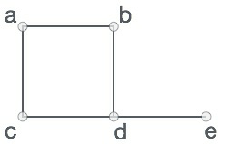

In the above graph,

V = {a, b, c, d, e}

E = {ab, ac, bd, cd, de}

**Graph Data Structure**

Mathematical graphs can be represented in data structure. We can represent a graph using an array of vertices and a two-dimensional array of edges. Before we proceed further, let's familiarize ourselves with some important terms −

* **Vertex** − Each node of the graph is represented as a vertex. In the following example, the labeled circle represents vertices. Thus, A to G are vertices. We can represent them using an array as shown in the following image. Here A can be identified by index 0. B can be identified using index 1 and so on.
* **Edge** − Edge represents a path between two vertices or a line between two vertices. In the following example, the lines from A to B, B to C, and so on represents edges. We can use a two-dimensional array to represent an array as shown in the following image. Here AB can be represented as 1 at row 0, column 1, BC as 1 at row 1, column 2 and so on, keeping other combinations as 0.
* **Adjacency** − Two node or vertices are adjacent if they are connected to each other through an edge. In the following example, B is adjacent to A, C is adjacent to B, and so on.
* **Path** − Path represents a sequence of edges between the two vertices. In the following example, ABCD represents a path from A to D.

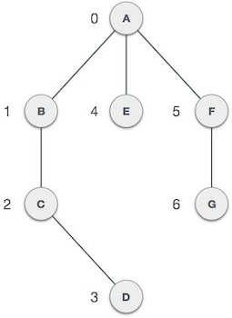

**Basic Operations**

Following are basic primary operations of a Graph −

* **Add Vertex** − Adds a vertex to the graph.
* **Add Edge** − Adds an edge between the two vertices of the graph.
* **Display Vertex** − Displays a vertex of the graph.

Depth First Search (DFS) algorithm traverses a graph in a depthward motion and uses a stack to remember to get the next vertex to start a search, when a dead end occurs in any iteration.

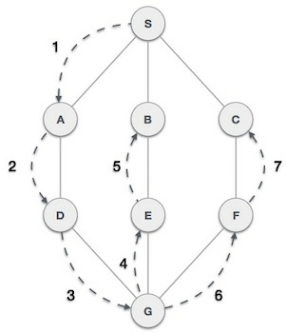

As in the example given above, DFS algorithm traverses from S to A to D to G to E to B first, then to F and lastly to C. It employs the following rules.

* **Rule 1** − Visit the adjacent unvisited vertex. Mark it as visited. Display it. Push it in a stack.
* **Rule 2** − If no adjacent vertex is found, pop up a vertex from the stack. (It will pop up all the vertices from the stack, which do not have adjacent vertices.)
* **Rule 3** − Repeat Rule 1 and Rule 2 until the stack is empty.

|  |  |  |
| --- | --- | --- |
| **Step** | **Traversal** | **Description** |
| 1 | Depth First Search Step One | Initialize the stack. |
| 2 | Depth First Search Step Two | Mark **S** as visited and put it onto the stack. Explore any unvisited adjacent node from **S**. We have three nodes and we can pick any of them. For this example, we shall take the node in an alphabetical order. |
| 3 | Depth First Search Step Three | Mark **A** as visited and put it onto the stack. Explore any unvisited adjacent node from A. Both **S** and **D** are adjacent to **A** but we are concerned for unvisited nodes only. |
| 4 | Depth First Search Step Four | Visit **D** and mark it as visited and put onto the stack. Here, we have **B** and **C** nodes, which are adjacent to **D** and both are unvisited. However, we shall again choose in an alphabetical order. |
| 5 | Depth First Search Step Five | We choose **B**, mark it as visited and put onto the stack. Here **B** does not have any unvisited adjacent node. So, we pop **B** from the stack. |
| 6 | Depth First Search Step Six | We check the stack top for return to the previous node and check if it has any unvisited nodes. Here, we find **D** to be on the top of the stack. |
| 7 | Depth First Search Step Seven | Only unvisited adjacent node is from **D** is **C** now. So we visit **C**, mark it as visited and put it onto the stack. |

As **C** does not have any unvisited adjacent node so we keep popping the stack until we find a node that has an unvisited adjacent node. In this case, there's none and we keep popping until the stack is empty.

Breadth First Search (BFS) algorithm traverses a graph in a breadthward motion and uses a queue to remember to get the next vertex to start a search, when a dead end occurs in any iteration.

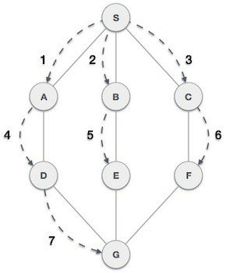

As in the example given above, BFS algorithm traverses from A to B to E to F first then to C and G lastly to D. It employs the following rules.

* **Rule 1** − Visit the adjacent unvisited vertex. Mark it as visited. Display it. Insert it in a queue.
* **Rule 2** − If no adjacent vertex is found, remove the first vertex from the queue.
* **Rule 3** − Repeat Rule 1 and Rule 2 until the queue is empty.

|  |  |  |
| --- | --- | --- |
| **Step** | **Traversal** | **Description** |
| 1 | Breadth First Search Step One | Initialize the queue. |
| 2 | Breadth First Search Step Two | We start from visiting **S** (starting node), and mark it as visited. |
| 3 | Breadth First Search Step Three | We then see an unvisited adjacent node from **S**. In this example, we have three nodes but alphabetically we choose **A**, mark it as visited and enqueue it. |
| 4 | Breadth First Search Step Four | Next, the unvisited adjacent node from **S** is **B**. We mark it as visited and enqueue it. |
| 5 | Breadth First Search Step Five | Next, the unvisited adjacent node from **S** is **C**. We mark it as visited and enqueue it. |
| 6 | Breadth First Search Step Six | Now, **S** is left with no unvisited adjacent nodes. So, we dequeue and find **A**. |
| 7 | Breadth First Search Step Seven | From **A** we have **D** as unvisited adjacent node. We mark it as visited and enqueue it. |

At this stage, we are left with no unmarked (unvisited) nodes. But as per the algorithm we keep on dequeuing in order to get all unvisited nodes. When the queue gets emptied, the program is over.

Tree represents the nodes connected by edges. We will discuss binary tree or binary search tree specifically.

Binary Tree is a special datastructure used for data storage purposes. A binary tree has a special condition that each node can have a maximum of two children. A binary tree has the benefits of both an ordered array and a linked list as search is as quick as in a sorted array and insertion or deletion operation are as fast as in linked list.

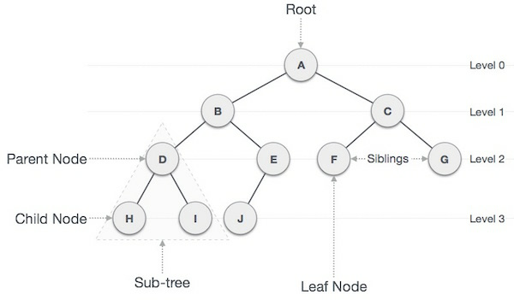

## Important Terms

Following are the important terms with respect to tree.

* **Path** − Path refers to the sequence of nodes along the edges of a tree.
* **Root** − The node at the top of the tree is called root. There is only one root per tree and one path from the root node to any node.
* **Parent** − Any node except the root node has one edge upward to a node called parent.
* **Child** − The node below a given node connected by its edge downward is called its child node.
* **Leaf** − The node which does not have any child node is called the leaf node.
* **Subtree** − Subtree represents the descendants of a node.
* **Visiting** − Visiting refers to checking the value of a node when control is on the node.
* **Traversing** − Traversing means passing through nodes in a specific order.
* **Levels** − Level of a node represents the generation of a node. If the root node is at level 0, then its next child node is at level 1, its grandchild is at level 2, and so on.
* **keys** − Key represents a value of a node based on which a search operation is to be carried out for a node.

## Binary Search Tree Representation

Binary Search tree exhibits a special behavior. A node's left child must have a value less than its parent's value and the node's right child must have a value greater than its parent value.

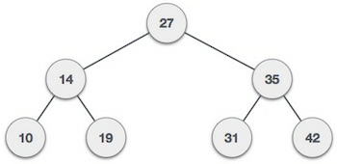

We're going to implement tree using node object and connecting them through references.

## Tree Node

The code to write a tree node would be similar to what is given below. It has a data part and references to its left and right child nodes.

struct node {

int data;

struct node *leftChild;

struct node *rightChild;

};

In a tree, all nodes share common construct.

## BST Basic Operations

The basic operations that can be performed on a binary search tree data structure, are the following −

* **Insert** − Inserts an element in a tree/create a tree.
* **Search** − Searches an element in a tree.
* **Preorder Traversal** − Traverses a tree in a pre-order manner.
* **Inorder Traversal** − Traverses a tree in an in-order manner.
* **Postorder Traversal** − Traverses a tree in a post-order manner.

We shall learn creating (inserting into) a tree structure and searching a data item in a tree in this chapter. We shall learn about tree traversing methods in the coming chapter.

## Insert Operation

The very first insertion creates the tree. Afterwards, whenever an element is to be inserted, first locate its proper location. Start searching from the root node, then if the data is less than the key value, search for the empty location in the left subtree and insert the data. Otherwise, search for the empty location in the right subtree and insert the data.

### Algorithm

If root is NULL

then create root node

return

If root exists then

compare the data with node.data

while until insertion position is located

If data is greater than node.data

goto right subtree

else

goto left subtree

endwhile

insert data

end If

### Implementation

The implementation of insert function should look like this −

void insert(int data) {

struct node *tempNode = (struct node*) malloc(sizeof(struct node));

struct node *current;

struct node *parent;

tempNode->data = data;

tempNode->leftChild = NULL;

tempNode->rightChild = NULL;

//if tree is empty, create root node

if(root == NULL) {

root = tempNode;

} else {

current = root;

parent = NULL;

while(1) {

parent = current;

//go to left of the tree

if(data < parent->data) {

current = current->leftChild;

//insert to the left

if(current == NULL) {

parent->leftChild = tempNode;

return;

}

}

//go to right of the tree

else {

current = current->rightChild;

//insert to the right

if(current == NULL) {

parent->rightChild = tempNode;

return;

}

}

}

}

}

## Search Operation

Whenever an element is to be searched, start searching from the root node, then if the data is less than the key value, search for the element in the left subtree. Otherwise, search for the element in the right subtree. Follow the same algorithm for each node.

### Algorithm

If root.data is equal to search.data

return root

else

while data not found

If data is greater than node.data

goto right subtree

else

goto left subtree

If data found

return node

endwhile

return data not found

end if

The implementation of this algorithm should look like this.

struct node* search(int data) {

struct node *current = root;

printf("Visiting elements: ");

while(current->data != data) {

if(current != NULL)

printf("%d ",current->data);

//go to left tree

if(current->data > data) {

current = current->leftChild;

}

//else go to right tree

else {

current = current->rightChild;

}

//not found

if(current == NULL) {

return NULL;

}

return current;

}

}

raversal is a process to visit all the nodes of a tree and may print their values too. Because, all nodes are connected via edges (links) we always start from the root (head) node. That is, we cannot randomly access a node in a tree. There are three ways which we use to traverse a tree −

* In-order Traversal
* Pre-order Traversal
* Post-order Traversal

Generally, we traverse a tree to search or locate a given item or key in the tree or to print all the values it contains.

## In-order Traversal

In this traversal method, the left subtree is visited first, then the root and later the right sub-tree. We should always remember that every node may represent a subtree itself.

If a binary tree is traversed **in-order**, the output will produce sorted key values in an ascending order.

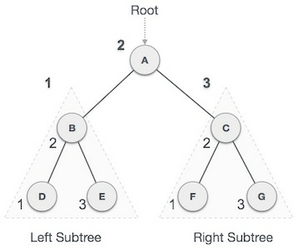

We start from **A**, and following in-order traversal, we move to its left subtree **B**. **B** is also traversed in-order. The process goes on until all the nodes are visited. The output of inorder traversal of this tree will be −

***D → B → E → A → F → C → G***

### Algorithm

Until all nodes are traversed −

**Step 1** − Recursively traverse left subtree.

**Step 2** − Visit root node.

**Step 3** − Recursively traverse right subtree.

## Pre-order Traversal

In this traversal method, the root node is visited first, then the left subtree and finally the right subtree.

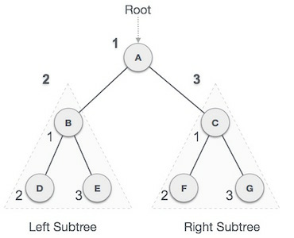

We start from **A**, and following pre-order traversal, we first visit **A** itself and then move to its left subtree **B**. **B** is also traversed pre-order. The process goes on until all the nodes are visited. The output of pre-order traversal of this tree will be −

***A → B → D → E → C → F → G***

### Algorithm

Until all nodes are traversed −

**Step 1** − Visit root node.

**Step 2** − Recursively traverse left subtree.

**Step 3** − Recursively traverse right subtree.

## Post-order Traversal

In this traversal method, the root node is visited last, hence the name. First we traverse the left subtree, then the right subtree and finally the root node.

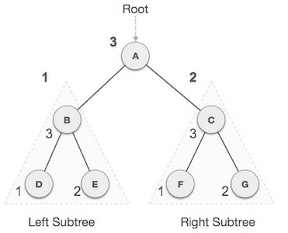

We start from **A**, and following Post-order traversal, we first visit the left subtree **B**. **B** is also traversed post-order. The process goes on until all the nodes are visited. The output of post-order traversal of this tree will be −

***D → E → B → F → G → C → A***

### Algorithm

Until all nodes are traversed −

**Step 1** − Recursively traverse left sub tree.

**Step 2** − Recursively traverse right sub tree.

**Step 3** − Visit root node.

A Binary Search Tree (BST) is a tree in which all the nodes follow the below-mentioned properties −

* The left sub-tree of a node has a key less than or equal to its parent node's key.
* The right sub-tree of a node has a key greater than to its parent node's key.

Thus, BST divides all its sub-trees into two segments; the left sub-tree and the right sub-tree and can be defined as −

left_subtree (keys) ≤ node (key) ≤ right_subtree (keys)

## Representation

BST is a collection of nodes arranged in a way where they maintain BST properties. Each node has a key and an associated value. While searching, the desired key is compared to the keys in BST and if found, the associated value is retrieved.

Following is a pictorial representation of BST −



We observe that the root node key (27) has all less-valued keys on the left sub-tree and the higher valued keys on the right sub-tree.

## Basic Operations

Following are the basic operations of a tree −

* **Search** − Searches an element in a tree.
* **Insert** − Inserts an element in a tree.
* **Pre-order Traversal** − Traverses a tree in a pre-order manner.
* **In-order Traversal** − Traverses a tree in an in-order manner.
* **Post-order Traversal** − Traverses a tree in a post-order manner.

## Node

Define a node having some data, references to its left and right child nodes.

struct node {

int data;

struct node *leftChild;

struct node *rightChild;

};

## Search Operation

Whenever an element is to be searched, start searching from the root node. Then if the data is less than the key value, search for the element in the left subtree. Otherwise, search for the element in the right subtree. Follow the same algorithm for each node.

### Algorithm

struct node* search(int data){

struct node *current = root;

printf("Visiting elements: ");

while(current->data != data){

if(current != NULL) {

printf("%d ",current->data);

//go to left tree

if(current->data > data){

current = current->leftChild;

} //else go to right tree

else {

current = current->rightChild;

}

//not found

if(current == NULL){

return NULL;

}

}

}

return current;

}

## Insert Operation

Whenever an element is to be inserted, first locate its proper location. Start searching from the root node, then if the data is less than the key value, search for the empty location in the left subtree and insert the data. Otherwise, search for the empty location in the right subtree and insert the data.

### Algorithm

void insert(int data) {

struct node *tempNode = (struct node*) malloc(sizeof(struct node));

struct node *current;

struct node *parent;

tempNode->data = data;

tempNode->leftChild = NULL;

tempNode->rightChild = NULL;

//if tree is empty

if(root == NULL) {

root = tempNode;

} else {

current = root;

parent = NULL;

while(1) {

parent = current;

//go to left of the tree

if(data < parent->data) {

current = current->leftChild;

//insert to the left

if(current == NULL) {

parent->leftChild = tempNode;

return;

}

} //go to right of the tree

else {

current = current->rightChild;

//insert to the right

if(current == NULL) {

parent->rightChild = tempNode;

return;

}

}

}

}

}

Hash Table is a data structure which stores data in an associative manner. In a hash table, data is stored in an array format, where each data value has its own unique index value. Access of data becomes very fast if we know the index of the desired data.

Thus, it becomes a data structure in which insertion and search operations are very fast irrespective of the size of the data. Hash Table uses an array as a storage medium and uses hash technique to generate an index where an element is to be inserted or is to be located from.

## Hashing

Hashing is a technique to convert a range of key values into a range of indexes of an array. We're going to use modulo operator to get a range of key values. Consider an example of hash table of size 20, and the following items are to be stored. Item are in the (key,value) format.

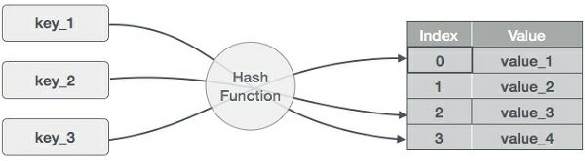

* (1,20)
* (2,70)
* (42,80)
* (4,25)
* (12,44)
* (14,32)
* (17,11)
* (13,78)
* (37,98)

|  |  |  |  |
| --- | --- | --- | --- |
| **Sr.No.** | **Key** | **Hash** | **Array Index** |
| 1 | 1 | 1 % 20 = 1 | 1 |
| 2 | 2 | 2 % 20 = 2 | 2 |
| 3 | 42 | 42 % 20 = 2 | 2 |
| 4 | 4 | 4 % 20 = 4 | 4 |
| 5 | 12 | 12 % 20 = 12 | 12 |
| 6 | 14 | 14 % 20 = 14 | 14 |
| 7 | 17 | 17 % 20 = 17 | 17 |
| 8 | 13 | 13 % 20 = 13 | 13 |
| 9 | 37 | 37 % 20 = 17 | 17 |

## Linear Probing

As we can see, it may happen that the hashing technique is used to create an already used index of the array. In such a case, we can search the next empty location in the array by looking into the next cell until we find an empty cell. This technique is called linear probing.

|  |  |  |  |  |
| --- | --- | --- | --- | --- |
| **Sr.No.** | **Key** | **Hash** | **Array Index** | **After Linear Probing, Array Index** |
| 1 | 1 | 1 % 20 = 1 | 1 | 1 |
| 2 | 2 | 2 % 20 = 2 | 2 | 2 |
| 3 | 42 | 42 % 20 = 2 | 2 | 3 |
| 4 | 4 | 4 % 20 = 4 | 4 | 4 |
| 5 | 12 | 12 % 20 = 12 | 12 | 12 |
| 6 | 14 | 14 % 20 = 14 | 14 | 14 |
| 7 | 17 | 17 % 20 = 17 | 17 | 17 |
| 8 | 13 | 13 % 20 = 13 | 13 | 13 |
| 9 | 37 | 37 % 20 = 17 | 17 | 18 |

## Basic Operations

Following are the basic primary operations of a hash table.

* **Search** − Searches an element in a hash table.
* **Insert** − inserts an element in a hash table.
* **delete** − Deletes an element from a hash table.

## DataItem

Define a data item having some data and key, based on which the search is to be conducted in a hash table.

struct DataItem {

int data;

int key;

};

## Hash Method

Define a hashing method to compute the hash code of the key of the data item.

int hashCode(int key){

return key % SIZE;

}

## Search Operation

Whenever an element is to be searched, compute the hash code of the key passed and locate the element using that hash code as index in the array. Use linear probing to get the element ahead if the element is not found at the computed hash code.

### Example

struct DataItem *search(int key) {

//get the hash

int hashIndex = hashCode(key);

//move in array until an empty

while(hashArray[hashIndex] != NULL) {

if(hashArray[hashIndex]->key == key)

return hashArray[hashIndex];

//go to next cell

++hashIndex;

//wrap around the table

hashIndex %= SIZE;

}

return NULL;

}

## Insert Operation

Whenever an element is to be inserted, compute the hash code of the key passed and locate the index using that hash code as an index in the array. Use linear probing for empty location, if an element is found at the computed hash code.

### Example

void insert(int key,int data) {

struct DataItem *item = (struct DataItem*) malloc(sizeof(struct DataItem));

item->data = data;

item->key = key;

//get the hash

int hashIndex = hashCode(key);

//move in array until an empty or deleted cell

while(hashArray[hashIndex] != NULL && hashArray[hashIndex]->key != -1) {

//go to next cell

++hashIndex;

//wrap around the table

hashIndex %= SIZE;

}

hashArray[hashIndex] = item;

}

## Delete Operation

Whenever an element is to be deleted, compute the hash code of the key passed and locate the index using that hash code as an index in the array. Use linear probing to get the element ahead if an element is not found at the computed hash code. When found, store a dummy item there to keep the performance of the hash table intact.

### Example

struct DataItem* delete(struct DataItem* item) {

int key = item->key;

//get the hash

int hashIndex = hashCode(key);

//move in array until an empty

while(hashArray[hashIndex] !=NULL) {

if(hashArray[hashIndex]->key == key) {

struct DataItem* temp = hashArray[hashIndex];

//assign a dummy item at deleted position

hashArray[hashIndex] = dummyItem;

return temp;

}

//go to next cell

++hashIndex;

//wrap around the table

hashIndex %= SIZE;

}

return NULL;

}